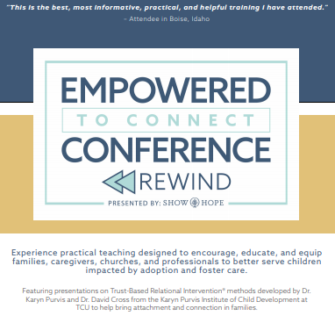
Friday, April 24 2020 3-8 pm
& Saturday, April 25 2020 9am-3pm
Hosted by Creative Counseling Connections and Sara Rodriguez, LCSW-C
23205 Wilderness Walk Court
Gaithersburg, MD 20882
ONLY 15 SPOTS AVAILABLE, register now!
To register, visit: http://creativecounselingconnections.com/tbri-parent-coaching-in-home-intensives/ or with questions email Sara at creativecounselingconnections@yahoo.com.

